Ex. No. : 1

Date:

**STUDY EXPERIMENT**

**AIM**

To study the functionality testing of various components: Digital storage oscilloscope (DSO), Function generator (FG), Regulated power supply (RPS) and to find the values of resistance of a given resistor using colour code. To know the procedure to test the functionality of various discrete electronic devices like diodes, transistors, JFET etc.,

**EQUIPMENTS REQUIRED**

Digital Storage Oscilloscope, function generator, regulated power supply, probe and resistors.

**THEORY**

The DSO is used to measure the frequency and amplitude of a signal wave. the signal wave is generated using a function generator and the power supply is provided through regulated power supply. The DSO consists of a screen which includes a graph. The signal waves can be displayed on the screen. the amplitude and frequency can be determined by observing the signal wave against the graph and performing the required adjustment.

Colour code is given on a resistor are used to determine the range of values of the resistor. The values assigned for various colours are as shown in the table.

The single band represents the tolerance. The colour of this band is identified and the corresponding tolerance value is noted. The set of three colour bands are observed from left to right. The number corresponding to the first, second and the third is noted. Thus the value of resistance is given by

R= $(ab×{10}^{c}±tolerence)Ω$

Where a,b and c are the first ,second and third numbers corresponding to the different colours of the band.

SYMBOL S AND DEVICES

|  |  |
| --- | --- |
|  | Resistor |
|  | capacitor |
|  | Inductor |
| +- | PN junction diode |
| +- | Zener diode |
| +- | Varactor diode |
| +- | Schottky diode |
| +- | Tunnel diode |
|  | Transistor(pnp) |
|  | Transistor(npn) |
|  | Field Effect Transistor(n channel) |
|  | Field Effect Transistor(p channel) |
| + - | Ammeter |
| +- | Voltmeter |

DIGITAL STORAGE OSCILLOSCOPE

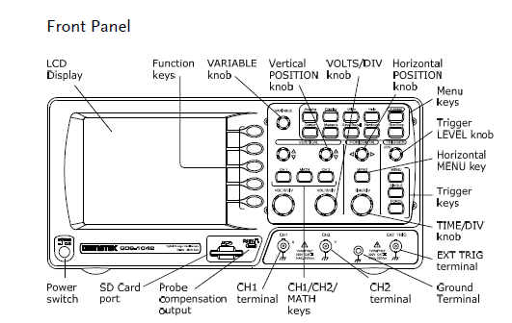

FUNCTION GENERATOR

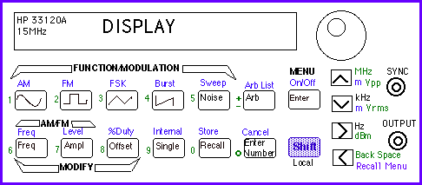

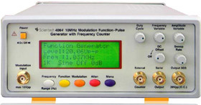

REGULATED POWER SUPPLY

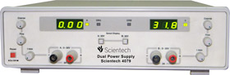

**RESISTOR COLOUR CODING**

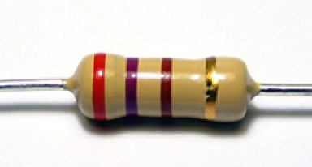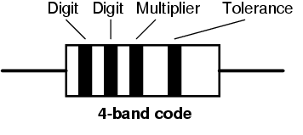

|  |  |
| --- | --- |
| NUMBER | COLOUR |
| 0 | Black |
| 1 | Brown |
| 2 | Red |
| 3 | Orange |
| 4 | Yellow |
| 5 | Green |
| 6 | Blue |
| 7 | Violet |
| 8 | Grey |
| 9 | White |
| TOLERENCE (%) | COLOUR |
| 5 | Gold |
| 10 | Silver |
| 20 | White |

**PROCEDURE**

1. The oscilloscope is kept in the grounded position. Adjust the trace line to a suitable position.
2. Before the power is supplied, it is checked that all knobs/ buttons are in the off mode.
3. With a probe, a function generator is connected to the oscilloscope.
4. Set the oscilloscope to display the function generated in either of the two channels.
5. Set the voltage division scale be set accordingly such that the amplitude measurement can be taken with accuracy.
6. With intensity control, focus control and trace rotation control knobs, the brightness, the sharpness and alignment of the waveform can be adjusted.
7. The input signal, if provided from an outside source is set to either CA or DC. Otherwise it is controlled by the function generator itself.
8. The time division scale is set at the rate at which the waveform is drawn across the screen.
9. Amplitude measurements are made at the central amplitude axis (central vertical line) and that value multiplied with the selected volt division scale gives the amplitude of the desired function (the measurement is made from the positive to negative peak of the wave).
10. Time measurements at central horizontal line (trace line) is taken and multiplied with time division scale to give the time period.
11. On observing the resistor, there will be three colour bands at one end and a single band at the other. The single band represents the tolerance. The colour of this band is identified and the corresponding tolerance value is noted. The set of three colour bands are observed from left to right. The number corresponding to the first, second and the third is noted. Thus the value of resistance is given by

R= $(ab×{10}^{c}±tolerence)Ω$

Where a,b and c are the first ,second and third numbers corresponding to the different colours of the band.

TABULAR COLUMN

To determine amplitude

|  |  |  |  |
| --- | --- | --- | --- |
| Waveform | Voltage division Reading (V) | Amplitude axis reading | Amplitude (V) |
|  |  |  |  |
|  |  |  |  |

To determine frequency

|  |  |  |  |  |
| --- | --- | --- | --- | --- |
| Waveform | Time division Reading (s) | Time period axis reading | Time period (s) | Frequency |
|  |  |  |  |  |
|  |  |  |  |  |

To find the value of resistance

|  |  |  |  |  |  |  |
| --- | --- | --- | --- | --- | --- | --- |
| Sl.no. | 1st band | 2nd band | 3rd band | Tolerence | Value Range(Ω) |  |
|  |  |  |  |  |  |  |

RESULT

1. The amplitudes and frequencies of various functions are taken.
2. The testing of various devices are studied.
3. From the colour coding, the values of resistors and capacitors are determined.
4. The frequency and amplitude of the generated wave function is determined and tabulated.